XWM on GitHub

TODO

Contents

Create a Git repository for XWM 2

# Create a Git repository for XWM

Open GitHub

and select Create a New Repository on your hard drive

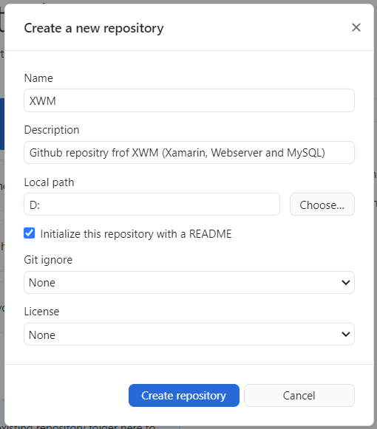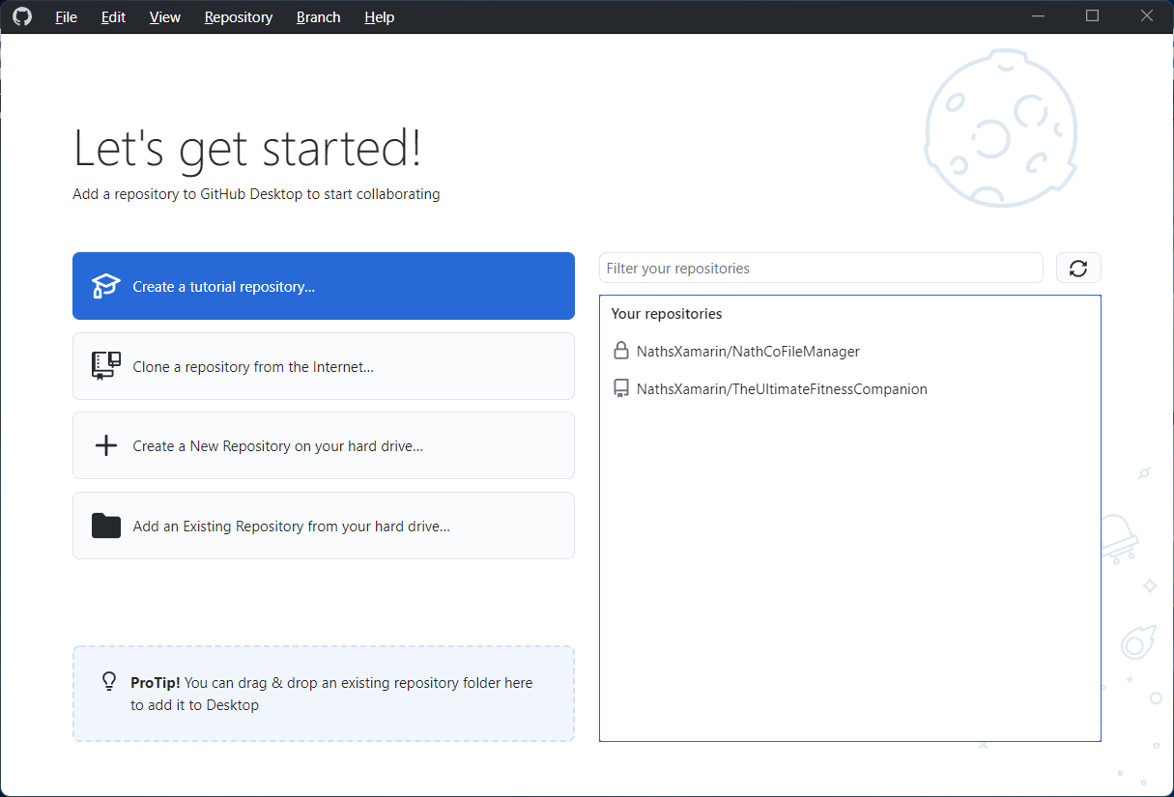

Enter the name and description

and click Create Repository

On the following page select Publish repository

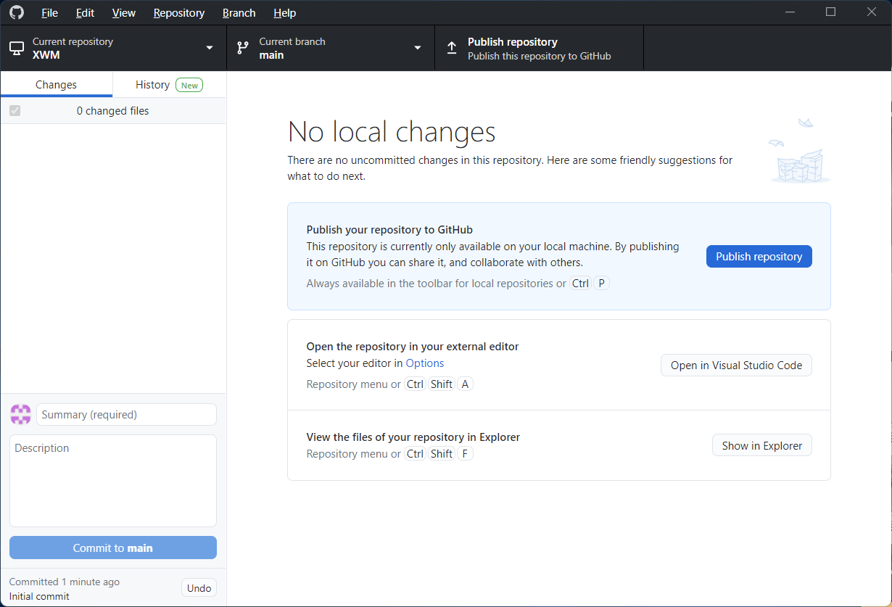

Deselect Keep this code private

then click Publish repository

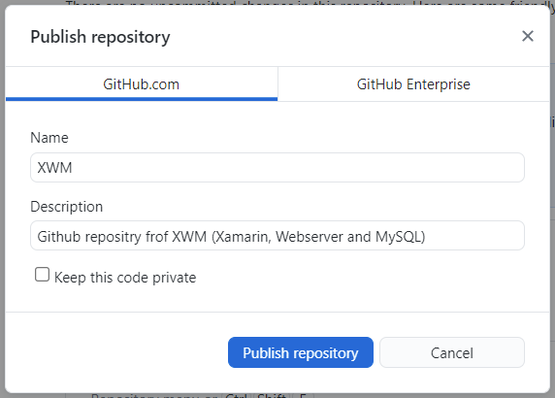

GitHub creates the following objects in D:/XWM

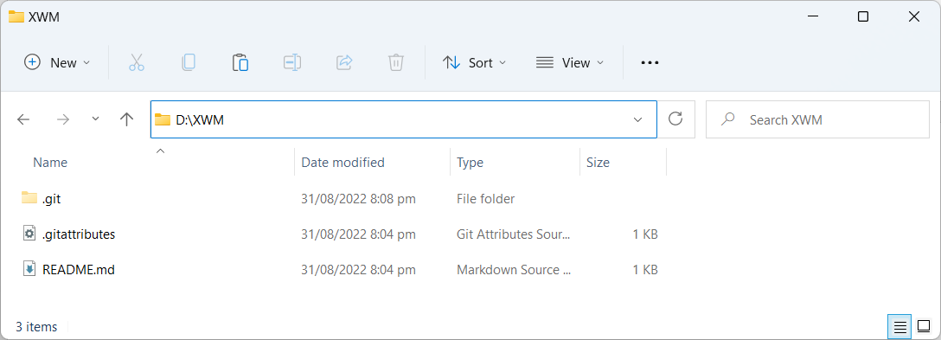

Create the following additional folders in D:/XWM

* Xamarin
* Webserver
* MySQL

ready for solutions and documentation.

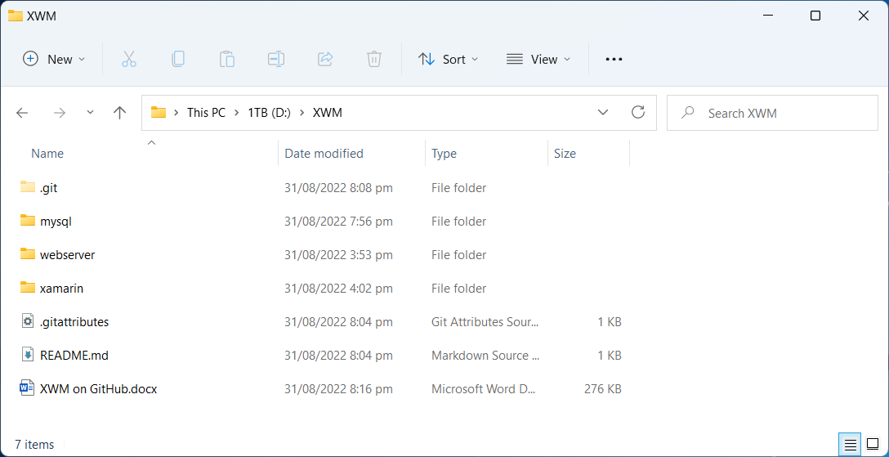

## Save changes on GitHub

In GitHub, add a commit summary

then click Commit to main

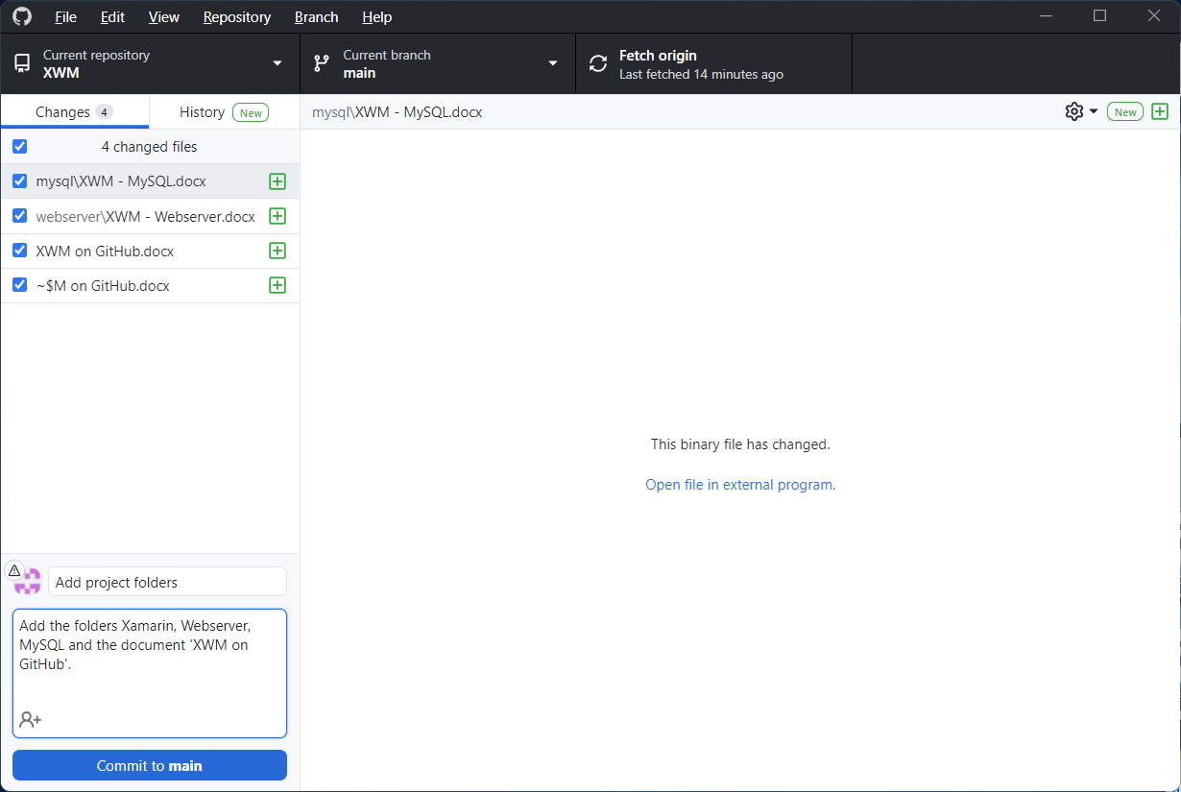

Push the changes to the remote repository

by clicking Push origin

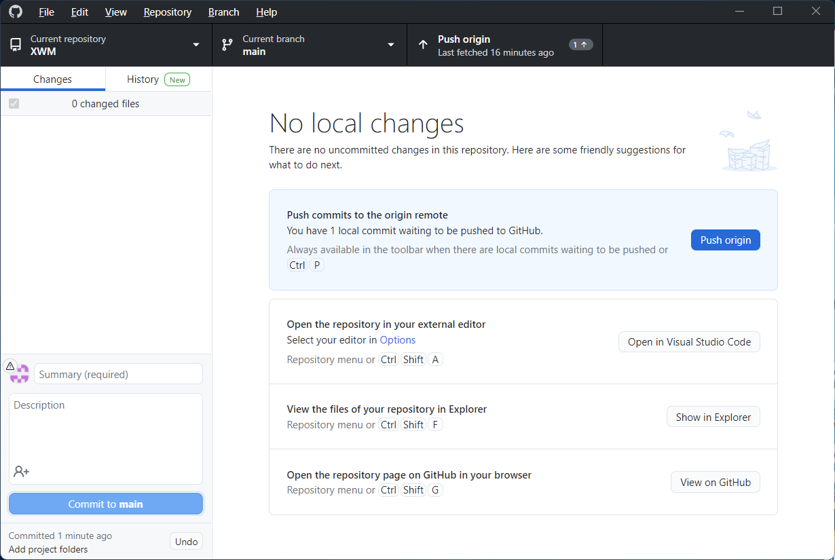

## View the project on GitHub

Check the project XWM

on the GitHub repository

by clicking View on GitHub

